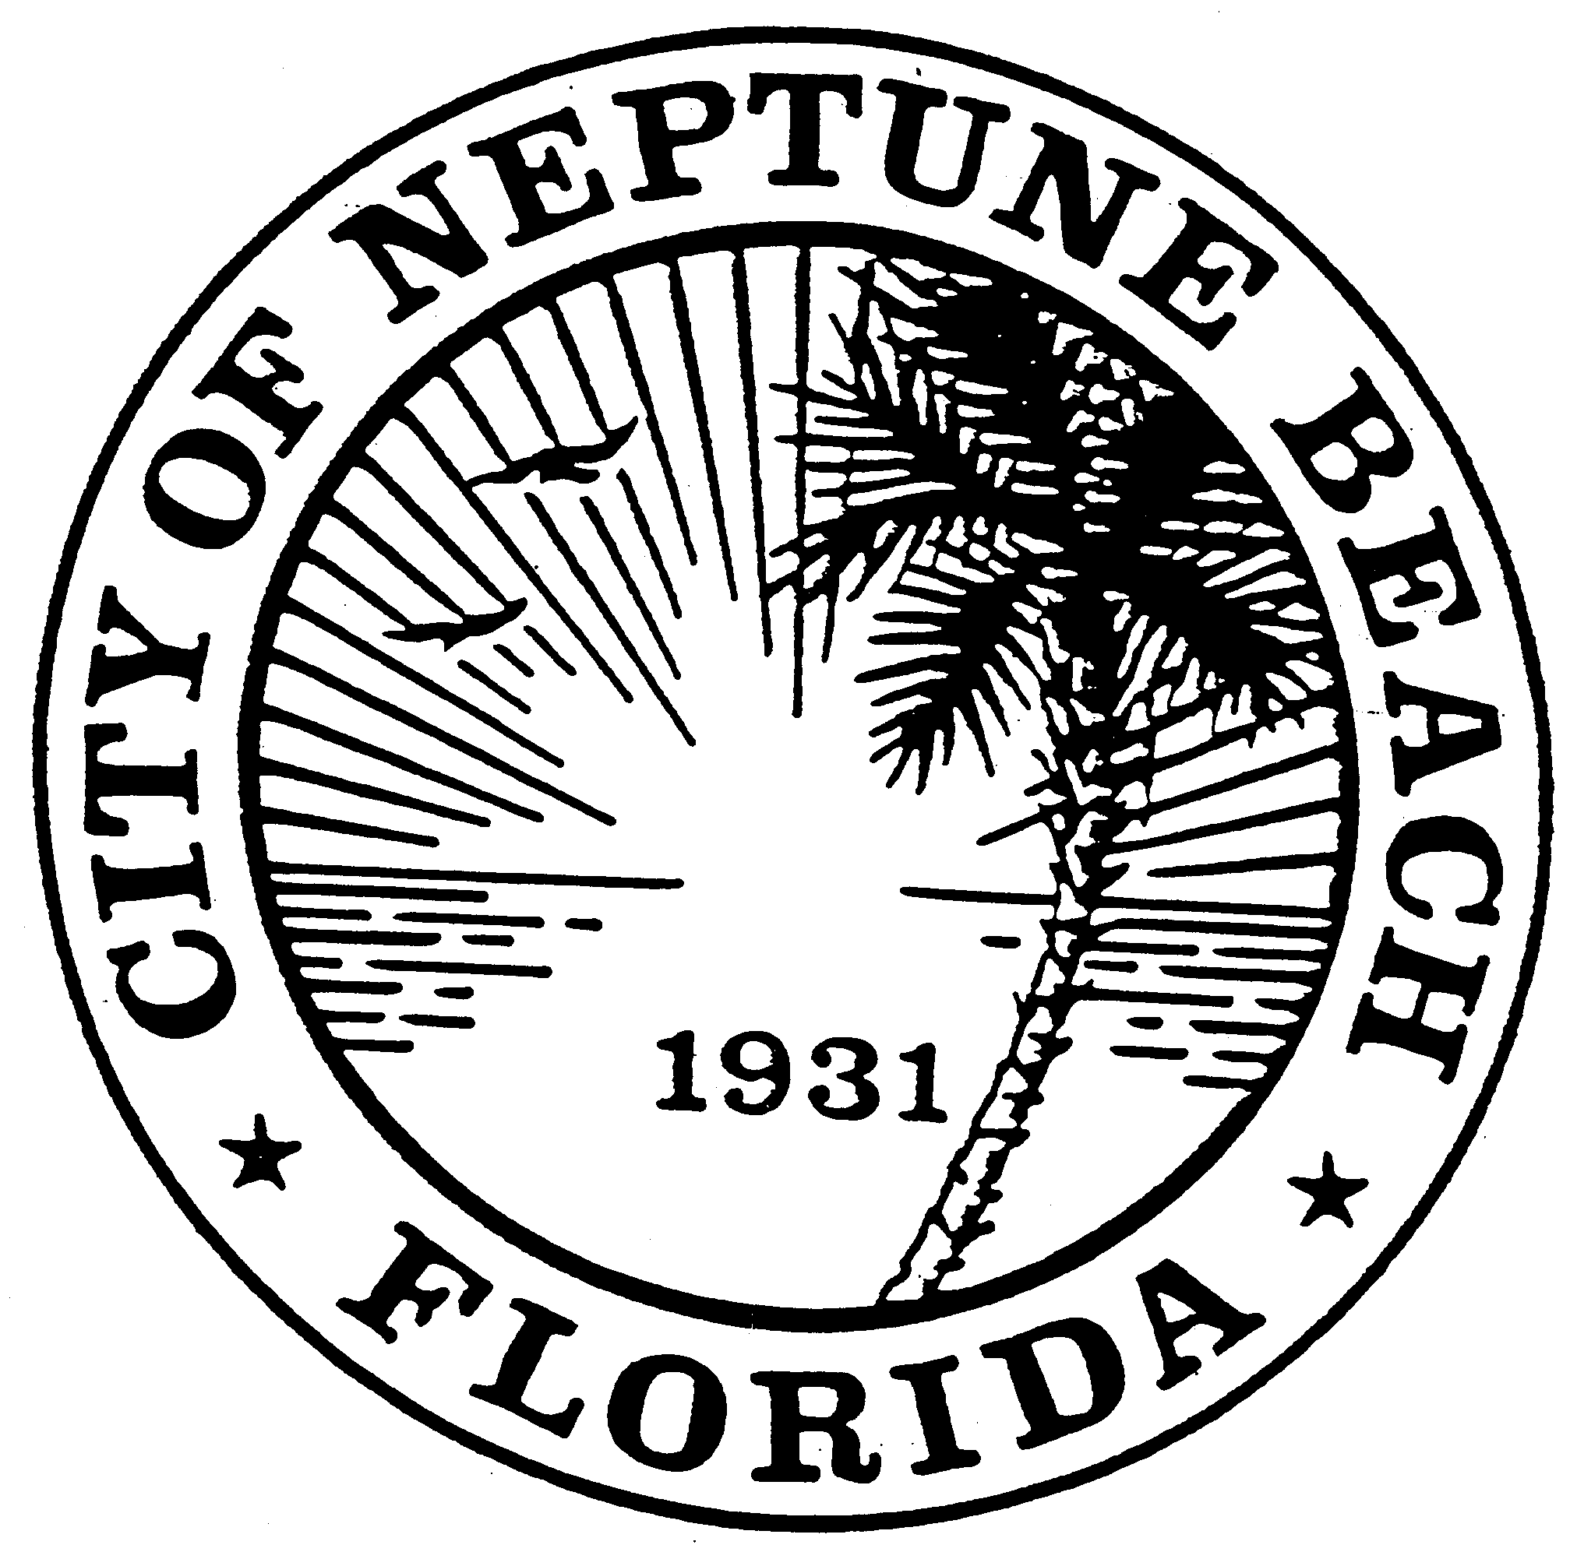

City of Neptune Beach
Planning and Community Development Department
116 First Street • Neptune Beach, Florida 32266-6140
(904) 270-2400 Ext. 36 • FAX (904) 270-2432

AGENDA

COMMUNITY DEVELOPMENT BOARD MEETING

APRIL 14, 2021 AT 6:00 PM

116 FIRST STREET

NEPTUNE BEACH, FL 32266

- Call to Order.
- Approval of Minutes: November 4, 2020 and February 10, 2021.
- V21-04 Application for variance as outlined in Chapter 27 Article III Division 8 of the Unified Land Development Code of Neptune Beach for the Hall Family Trust C/O Fredrick S. Hall for the property known as 517 Magnolia Street (RE#172481-0020). The request is to vary section 27-27-330(a)(1) Fences, walls and hedges. The request is to install an 8-foot tall fence with a double gate facing 5th St and Jarboe Park.

- V21-05 Application for variance as outlined in Chapter 27 Article III Division 8 of the Unified Land Development Code of Neptune Beach for Joshua & Erica Flamm for the property known as 511 Bowles Street (RE#173211-0000). The request is to vary Section 27-238(2) and Table-27-229-1 Maximum lot coverage in order to building a swimming pool.

- SE21-01 Application for a special exception as outlined in Chapter 27, Article 3 Division 9 and Section 27-226(j)(3)b of the Unified Land Development Code. Allowable uses by special exception in the C-3 zoning district. The application is made by Neptune Beach FL Realty, LLC for the property known as 580 Atlantic Blvd. (RE# 172395-0130). The applicant seeks approval for a special exception permit for outdoor seating/dining for an accessory restaurant use to the retail of a future Publix at 580 Atlantic Blvd.

- Election of Chair and Vice-Chair for a period of one year.

- Open Discussion.

- Adjournment

This meeting will be a hybrid in-person and a webinar conducted electronically meeting. Space for the in-person meeting will be limited due to social distancing requirements. In an addition to in-person comments based on the limited availability, members of the public may also provide written comments in the following manner:
Registered webinar participants can also share comments live during the meeting; you must request to do this using the “raise your hand” feature during “Comments from the Public” portion of the meeting.

The meeting can be observed in the following ways:

You may register to attend the GoToWebinar and view the meeting on your computer or dial in and listen on your telephone by visiting the following link:

https://attendee.gotowebinar.com/register/9159014736704992528

For questions or additional information, please contact the City Clerk’s office at (904) 270-2400, ext. 30

Board Members and Residents attending public meetings can use the code US74 to validate their parking session at no cost. After 5:30 on the date of the meeting, follow these steps:
- Make sure you are parked in a North Beaches public parking space – we can’t validate valet parking or parking in private lots.
- To use a kiosk: Using a nearby kiosk, press the Start button and then select 2 to enter your plate and the validation code.
- To use the Flowbird app: Tap the nearest yellow balloon and tap “Park here.” From the payment screen, select “Redeem a code” at the top. Confirm your information and tap “Purchase” – the price will show “Free.”

