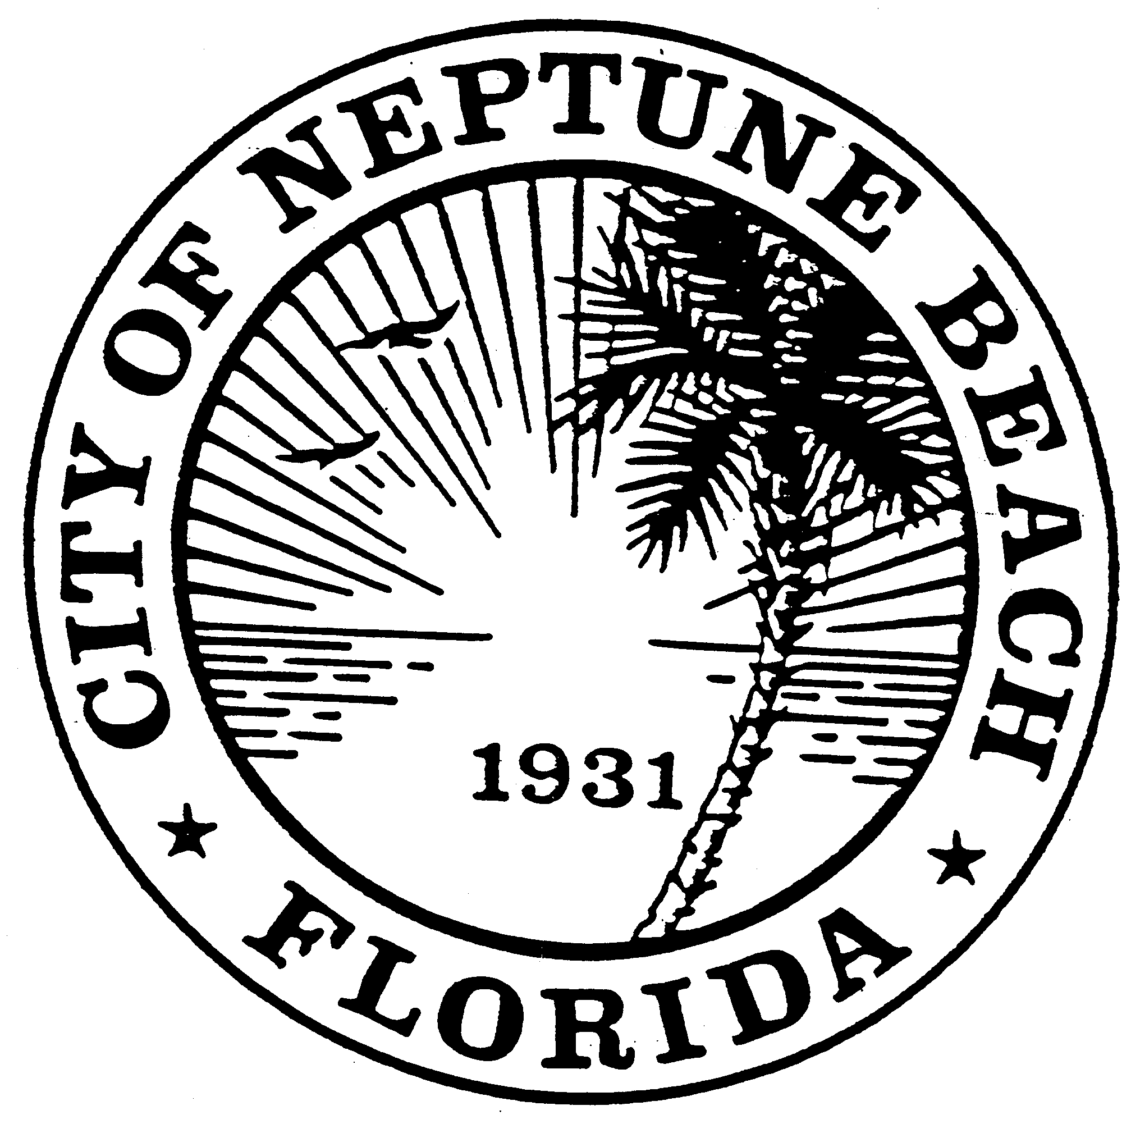

City of Neptune Beach
Planning and Community Development Department
116 First Street • Neptune Beach, Florida 32266-6140
(904) 270-2400 Ext. 36 • FAX (904) 270-2432

AGENDA

COMMUNITY DEVELOPMENT BOARD MEETING

FEBRUARY 10, 2021 AT 6:00 PM

116 FIRST STREET

NEPTUNE BEACH, FL 32266

- Call to Order.

- V21-01 Application for variance as outlined in Chapter 27 Article III Division 8 of the Unified Land Development Code of Neptune Beach for Richard Farino for the property known as 234 Windswept Circle (RE#178077-5012). The request is to vary section 27-238(4) Maximum Lot coverage for the construction of a Florida Room.

- V21-02 Application for variance as outlined in Chapter 27 Article III Division of the Unified Land Development Code of Neptune Beach for Mitchell McCue for the property known as 1410 Florida Blvd (RE#17738-0100). The request is to vary Table-27-229-1 for the rear yard setback to build an attached garage on the north side of the existing house.

- V21-03 Application for variance as outlined in Chapter 27 Article III Division of the Unified Land Development Code of Neptune Beach for Wesley & Melissa Kirkland for the property known as 809 Davis Street (RE#17403-0040). The request is to vary Table-27-229-1 for the rear and north side yard to construct an addition attached by a breezeway.

- Annual training session for all members with the City Attorney as required by Section 27-37(m). Topics to include: Procedures, Sunshine and Public Record laws.

- Open Discussion.

- Adjourn.

This meeting will be a hybrid in-person and a webinar conducted electronically meeting. Space for the in-person meeting will be limited due to social distancing requirements. In an addition to in-person comments based on the limited availability, members of the public may also provide written comments in the following manner:
Registered webinar participants can also share comments live during the meeting; you must request to do this using the “raise your hand” feature during “Comments from the Public” portion of the meeting.

The meeting can be observed in the following ways:

You may register to attend the GoToWebinar and view the meeting on your computer or dial in and listen on your telephone by visiting the following link:

https://attendee.gotowebinar.com/register/8455861656192492558
TO USE YOUR COMPUTER'S AUDIO:
When the webinar begins, you will be connected to audio using your computer's microphone and speakers (VoIP). A headset is recommended.

--OR-- TO USE YOUR TELEPHONE:
If you prefer to use your phone, you must select "Use Telephone" after joining the webinar and call in using the numbers below.
United States: +1 (415) 655-0052 Access Code: 309-071-246 Audio PIN: Shown after joining the webinar

Attendees joining via computer/smart device can refer to instructions below on how to join the webinar at: https://support.goto.com/webinar/how-to-join-attendees

For questions or additional information, please contact the City Clerk’s office at (904) 270-2400, ext. 30

