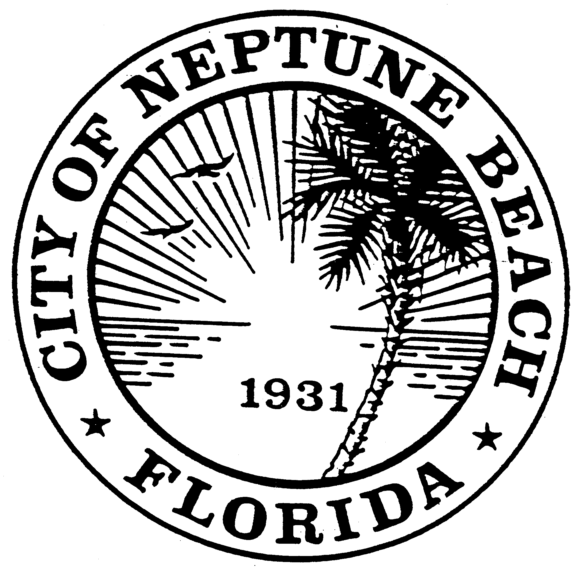

City of Neptune Beach
Planning and Community Development Department
116 First Street • Neptune Beach, Florida 32266-6140
(904) 270-2400 Ext. 36 • FAX (904) 270-2432

AGENDA

(REVISED)

COMMUNITY DEVELOPMENT BOARD MEETING

OCTOBER 14, 2020 AT 6:00 PM

116 FIRST STREET

NEPTUNE BEACH, FL 32266

- Call to Order.

- Approval of minutes for the September 16, 2020 meeting.

- Proposed ordinance amending Chapter 27, Unified Land Development Regulations; Article IV, Land Use; Sections 27-226(i)(2)(f) and 27-226(j)(2)(e)-Allowable uses within zoning districts (add Microblading, Permanent Cosmetics, Micropigmentation and similar care services to be considered as tattoo artistry as regulated by FL 381.00771-381.00791 and Chapter 64E-28 of the Florida Administrative Code yet restricting tattoo artistry that is not specific to permanent cosmetics, where microblading is incorporated as a supplemental yet permitted use in the zoning district in which personal services including beauty salons are a permitted use in C-2 and C-3 zoning districts) and Section 27-15-Definitions adding definition of microblading and permanent cosmetics.

- CDB20-03SE Application for a special exception and preliminary development permit as outlined in Chapter 27, Article 3 of the Unified Land Development Code of Neptune Beach for the property owner Neptune Square LV, LLC Et AL/Seminole Shoppes LLC. The request is to add a covered outdoor seating/dining area on private property in front of the property known as for 628 Atlantic Blvd. Suite #1 (RE# 172394-1700) per Section 27-226(j)(3)b-Allowable uses within zoning districts.

- V20-09 Application for variance as outlined in Chapter 27, Article 3 Division 8 of the Unified Land Development Code of Neptune Beach for the property owner Southcoast Beaches, II, LLC and tenants Jax Surf and Paddle, LLC. Variance request to Special restrictions and conditions on allowable uses within zoning districts Sections 27-227(6)(1), 27-227(6)(2) & 27-227(6)(3). The request is to enclose a space of the City’s right-of-way adjacent to 241 Atlantic Blvd Suite 102 (RE#172787-0020) in order to extend their retail offerings.

- CDB20-05 Application for Art Project as outline in Chapter 27 Section 27-596 for the property owned by Seahorse NB, LLC located at 120 Atlantic Blvd. The request is to paint a mural on the south wall facing Lemon Street of the Seahorse Oceanfront Inn.

- V20-05 Application for variance as outlined in Chapter 27, Article 3 Division 8 of the Unified Land Development Code of Neptune Beach for Melinda Monti for the property known as 109 North Street (RE#173131-0000). The request is to vary section 27-238(a)(4) Maximum lot coverage. The request is to increase the maximum lot coverage restriction for the installation of a swimming pool.

- V20-08 Application for variance as outlined in Chapter 27, Article 3 Division 8 of the Unified Land Development Code of Neptune Beach for Edward Skinner Jones Revocable Trust for the property known as 98 Walnut Street (RE#172746-0000). The request is to vary Table 27-229-1 R-4 flexible front yard and interior side yard setbacks to construct a new home and pool.

- CDB20-05SE Application for a special exception and preliminary development permit as outlined in Chapter 27, Article 3 Section 27-226(c)(3)a of the Unified Land Development Code of Neptune Beach for the property formerly known as 2004 Forest Avenue (Re#177490-0000). This property is owned by the City of Neptune Beach. The request is to construct a new Senior Center in the R-1 zoning district.

- Open Discussion.

- Adjourn.

