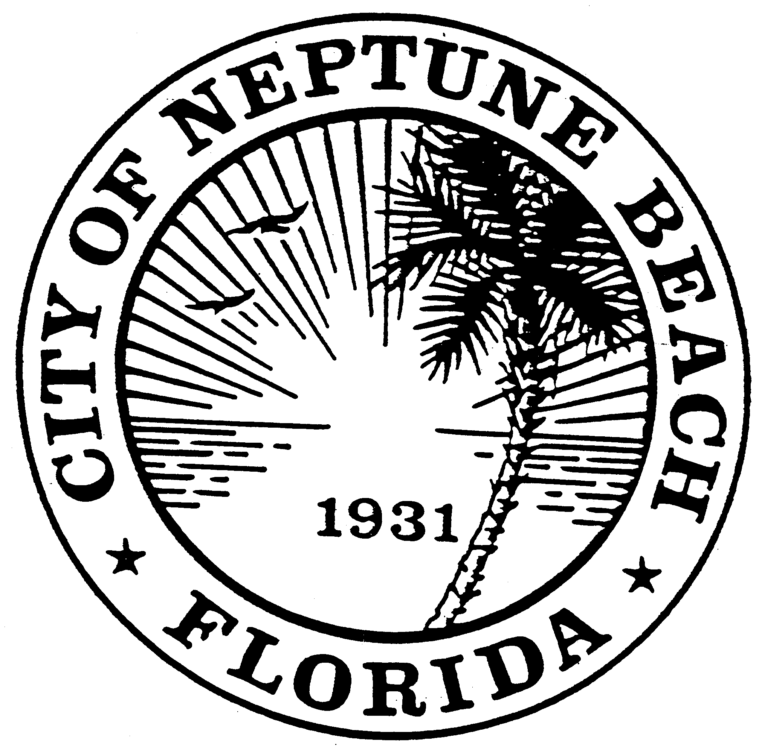

City of Neptune Beach
Community Development
116 First Street • Neptune Beach, Florida 32266-6140
(904) 270-2400 Ext. 36 • FAX (904) 270-2432

AGENDA

COMMUNITY DEVELOPMENT BOARD MEETING

August 14, 2019

(REVISED)

CITY COUNCIL CHAMBERS

116 FIRST STREET

NEPTUNE BEACH, FL 32266

- Call to Order and Roll Call.

- Disclosure of ex-parte communications.

- Approval of July 10, 2019 minutes.

- CDB 19-09 Application for a replat as outlined in Chapter 27, Article 3 of the Unified Land Development Code of Neptune Beach for Eugene and Lorraine Kiernan for property known as 214-216 Bowles Street, (RE# 173037-0000). The subject property is located on the north side of Bowles Street. The applicants are requesting to subdivide the property into two equal size lots.

- CDB 19-10 Application for development permit review as outlined in Chapter 27, Article 2 of the Unified Land Development Code of Neptune Beach for Margaret Cornelius for the property known as 0 Atlantic Blvd. (173326-0000). This property is a vacant parcel on the south side of Atlantic Blvd, adjacent to 1552 Atlantic Blvd. in the C-2 zoning district. The applicant is proposing to a new commercial building approximately 1600 square feet and parking.

- CDB V19-11 Application for variance as outlined in Chapter 27, Article 8 of the Unified Land Development Code of Neptune Beach for Meatball Enterprises, LLC and Nicole & Derek DeLoreto for the property known as 0 Poinciana Road (RE#173340-0000) This property is a vacant parcel on the south side of Poinciana Road in the C-2 zoning district that abutting 2130 Florida Blvd. The request is to vary Table 27-229-1 to the both side yards setback to build a commercial building in the future.
- Open Discussion

- Adjourn.

