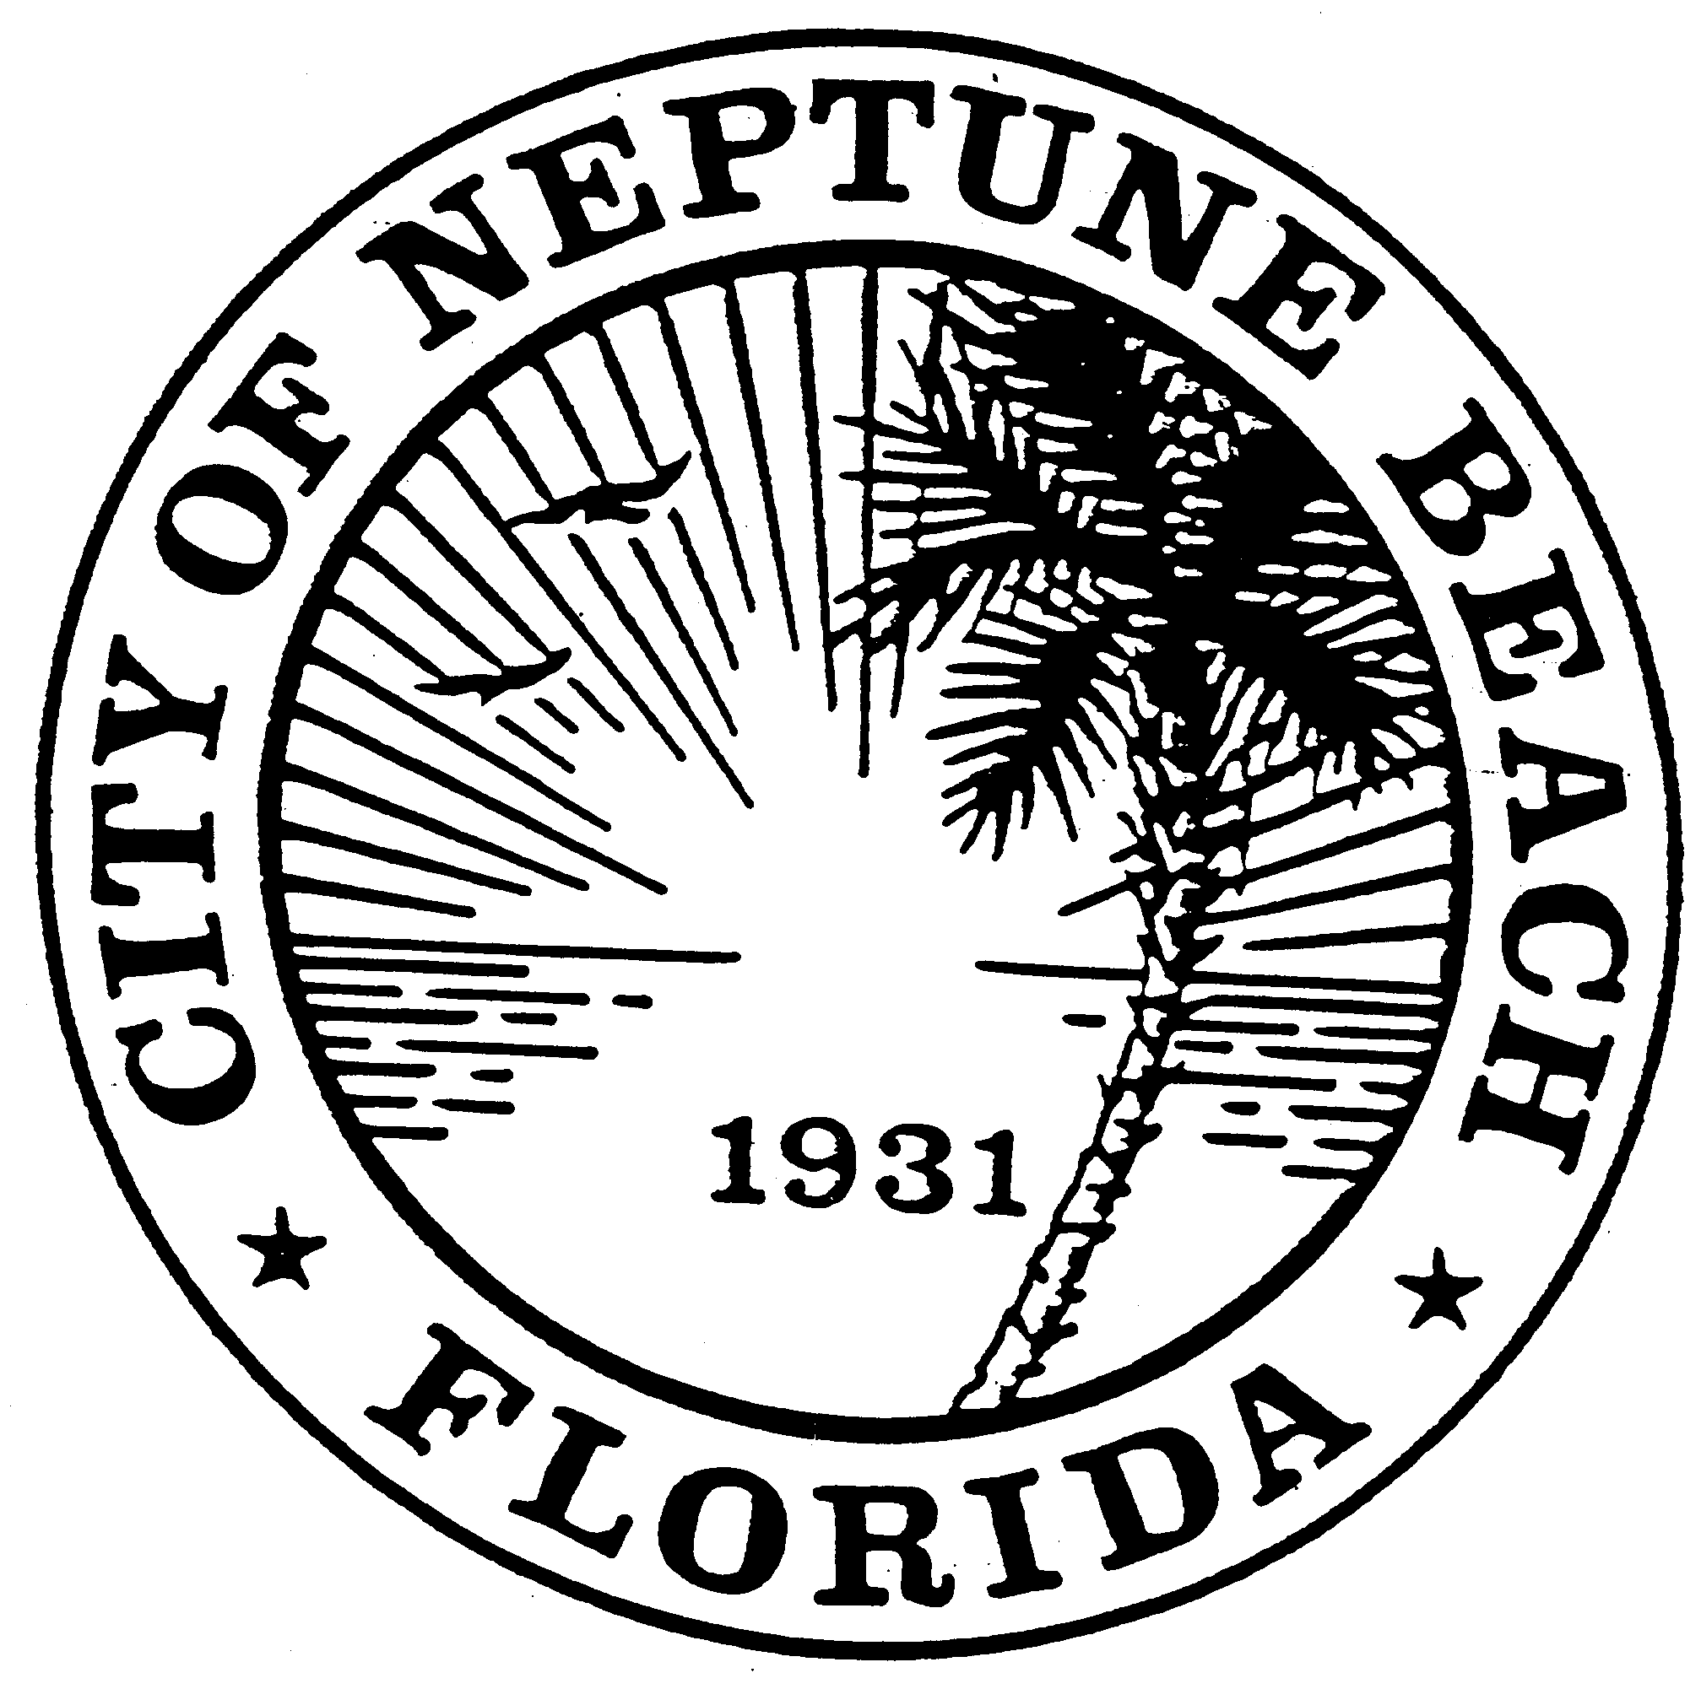

City of Neptune Beach
Community Development Department
116 First Street • Neptune Beach, Florida 32266-6140
(904) 270-2400 Ext. 36 • FAX (904) 270-2432

AGENDA

COMMUNITY DEVELOPMENT BOARD MEETING

JULY 8, 2020

CITY COUNCIL CHAMBERS

116 FIRST STREET

NEPTUNE BEACH, FL 32266

- Call to Order and Roll Call.

- Disclosure of ex-parte communications.

- Approval of the February 12, March 11 and June 10, 2020 minutes.

- V20-01 Application for variance as outlined in Chapter 27, Article 8 of the Unified Land Development Code of Neptune Beach for Neptune Beach Fl Realty, LLC for the property known as 540-580 Atlantic Blvd (RE#172395-0130). This property is former Lucky’s Market in the Neptune Beach Plaza. The variance request is to provide relief from Note 6 of Table 27-229-1 to remove the 1000 linear foot requirement businesses that operate under common business ownership or management, share a warehouse or distribution facility, or otherwise operate as an associated, integrated or cooperative business shall not exceed a combined sixty thousand (60,000) square feet of total gross floor area in aggregate.

- V20-02 Application for variance as outlined in Chapter 27, Article 8 of the Unified Land Development Code of Neptune Beach for Patrick and Amy O’Grady for the property known as 2132 Acacia Road (RE#173389-0000). The request is to vary section 27-238(2) Maximum Lot coverage for the construction of a swimming pool and decking.

- V20-03 Application for variance as outlined in Chapter 27, Article 8 of the Unified Land Development Code of Neptune Beach for Melinda Monti for the property known as 109 North Street (RE#173131-0000). The request is to vary section Table-27-229-1 for the front and east side yard and increase the floor area ratio to construct a 2nd story deck, enclose the carport and 2nd floor porch for living space.

- V20-04 Application for variance as outlined in Chapter 27, Article 8 of the Unified Land Development Code of Neptune Beach for Janice Gregory for the property known as 404 Sanibel Court (RE#172403-2280). The request is to vary section 27-328(a)(2) to construct a storage shed closer than 3 feet to the property line and less than 10 feet from the principle structure.

- Open Discussion.
- Adjourn.

