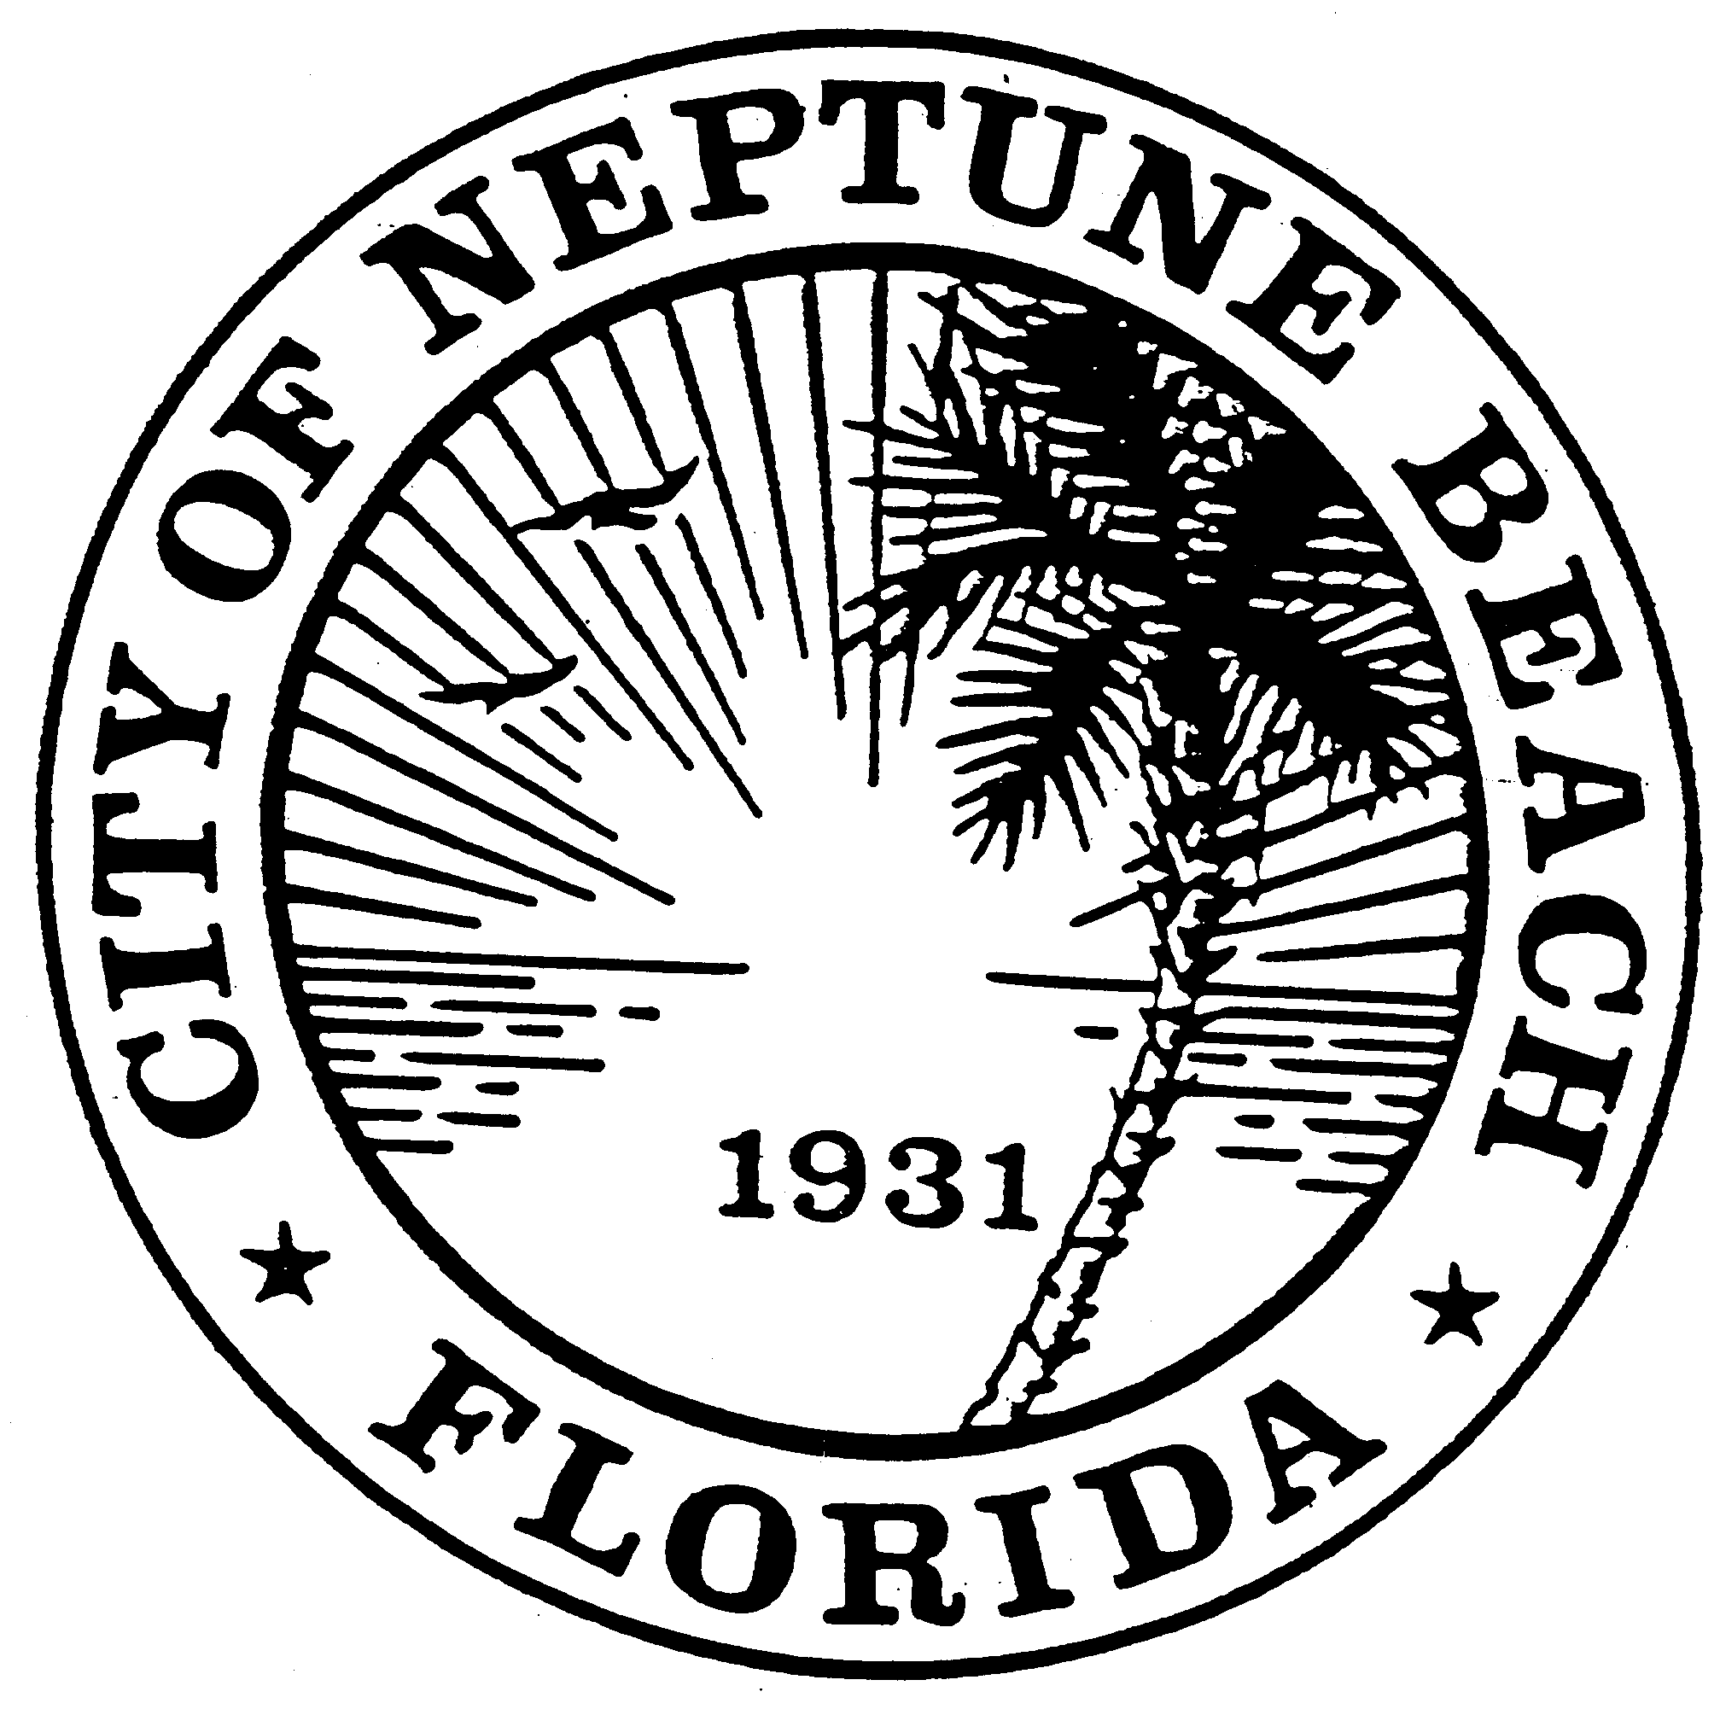

City of Neptune Beach
Planning and Community Development Department
116 First Street • Neptune Beach, Florida 32266-6140
(904) 270-2400 Ext. 36 • FAX (904) 270-2432

AGENDA

COMMUNITY DEVELOPMENT BOARD MEETING

(AMENDED 6/4/19)

JUNE 12, 2019

CITY COUNCIL CHAMBERS

116 FIRST STREET

NEPTUNE BEACH, FL 32266

- Call to Order and Roll Call.

- Disclosure of ex-parte communications.

- Approval of May 8, 2019 minutes.

- CDB V19-06 Application for variances as outlined in Chapter 27, Article 3 of the Unified Land Development Code of Neptune Beach for Michael Wilson, et al for the property known as 121 and 123 Cedar Street (RE# 172706-0000). The request is to vary section 27-229-1 for the corner side yard, front yard and interior side yard setbacks. The proposed variances to enclose the existing porch/step area on the west side of the house and enclose the covered porch area on the front of the house. The applicant is proposing to convert the duplex into a single-family home.
- Election of Chair and Vice-Chair for a period of one year.

- Adjourn

