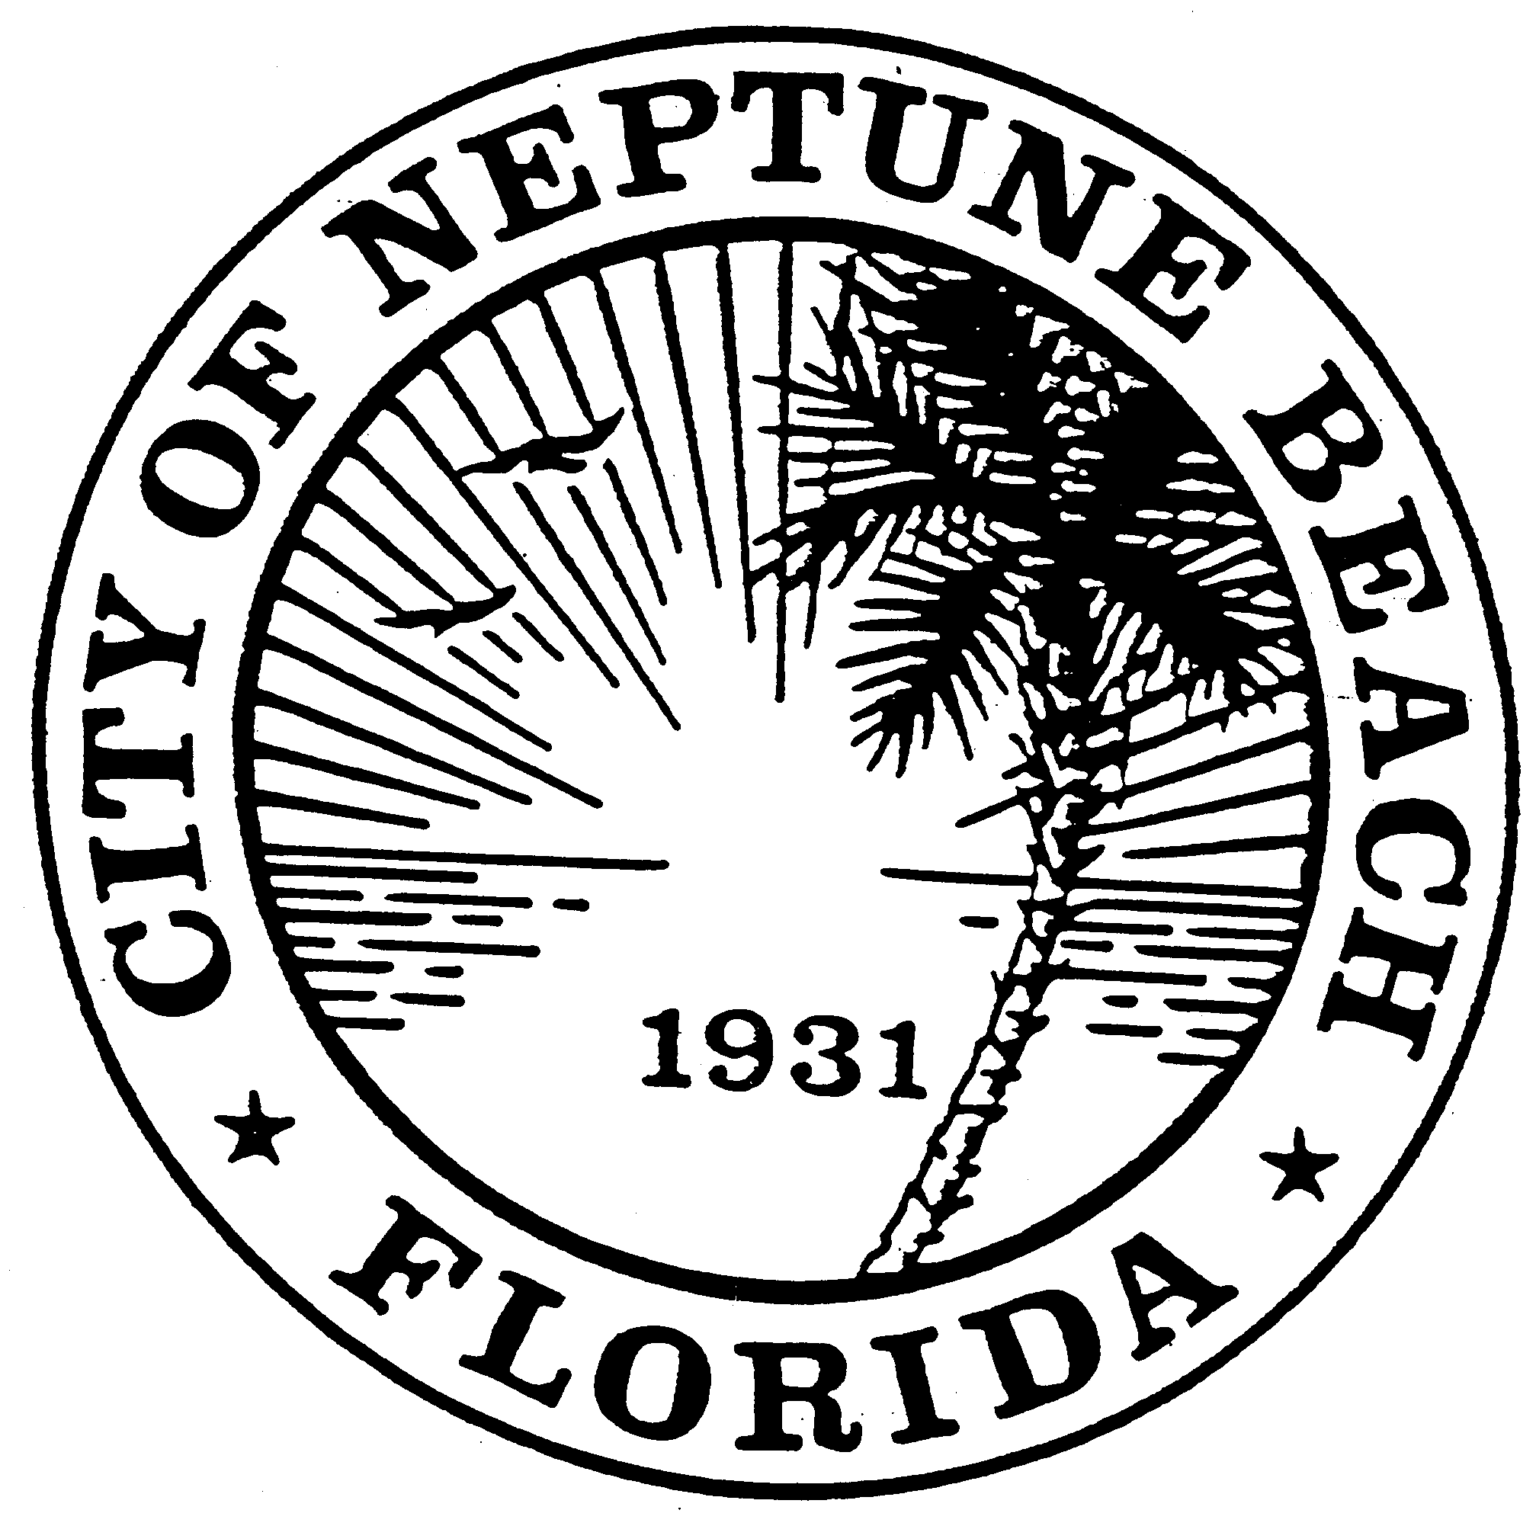

City of Neptune Beach
Community Development
116 First Street • Neptune Beach, Florida 32266-6140
(904) 270-2400 Ext. 36 • FAX (904) 270-2432

AGENDA

COMMUNITY DEVELOPMENT BOARD MEETING

OCTOBER 9, 2019

CITY COUNCIL CHAMBERS

116 FIRST STREET

NEPTUNE BEACH, FL 32266

- Call to Order and Roll Call.

- Disclosure of ex-parte communications.

- Approval of September 11, 2019 minutes.

- An ordinance of the City of Neptune Beach, Florida, enacting a temporary moratorium to prohibit the acceptance or processing of any application for a development order or any other official action of the City having the effect of permitting or allowing for the application of a plat or replat in the R-4 zoning district as set forth in Chapter 27, Unified Land Development Regulations, Division 3 Section 27-101 through 27-102, platting requirements Chapter 27, Unified Land Development Regulations, Division 4 Section 27-105 through 27-109, minor replat requirements, and 27-110 temporary moratorium; providing for a temporary moratorium term to be extended if necessary by the City Council; providing for early termination; providing for conflicts; providing for severability; providing an effective date.

- Adoption of Board Procedures as required by Section 27-40.
- Open Discussion

- Adjourn.

