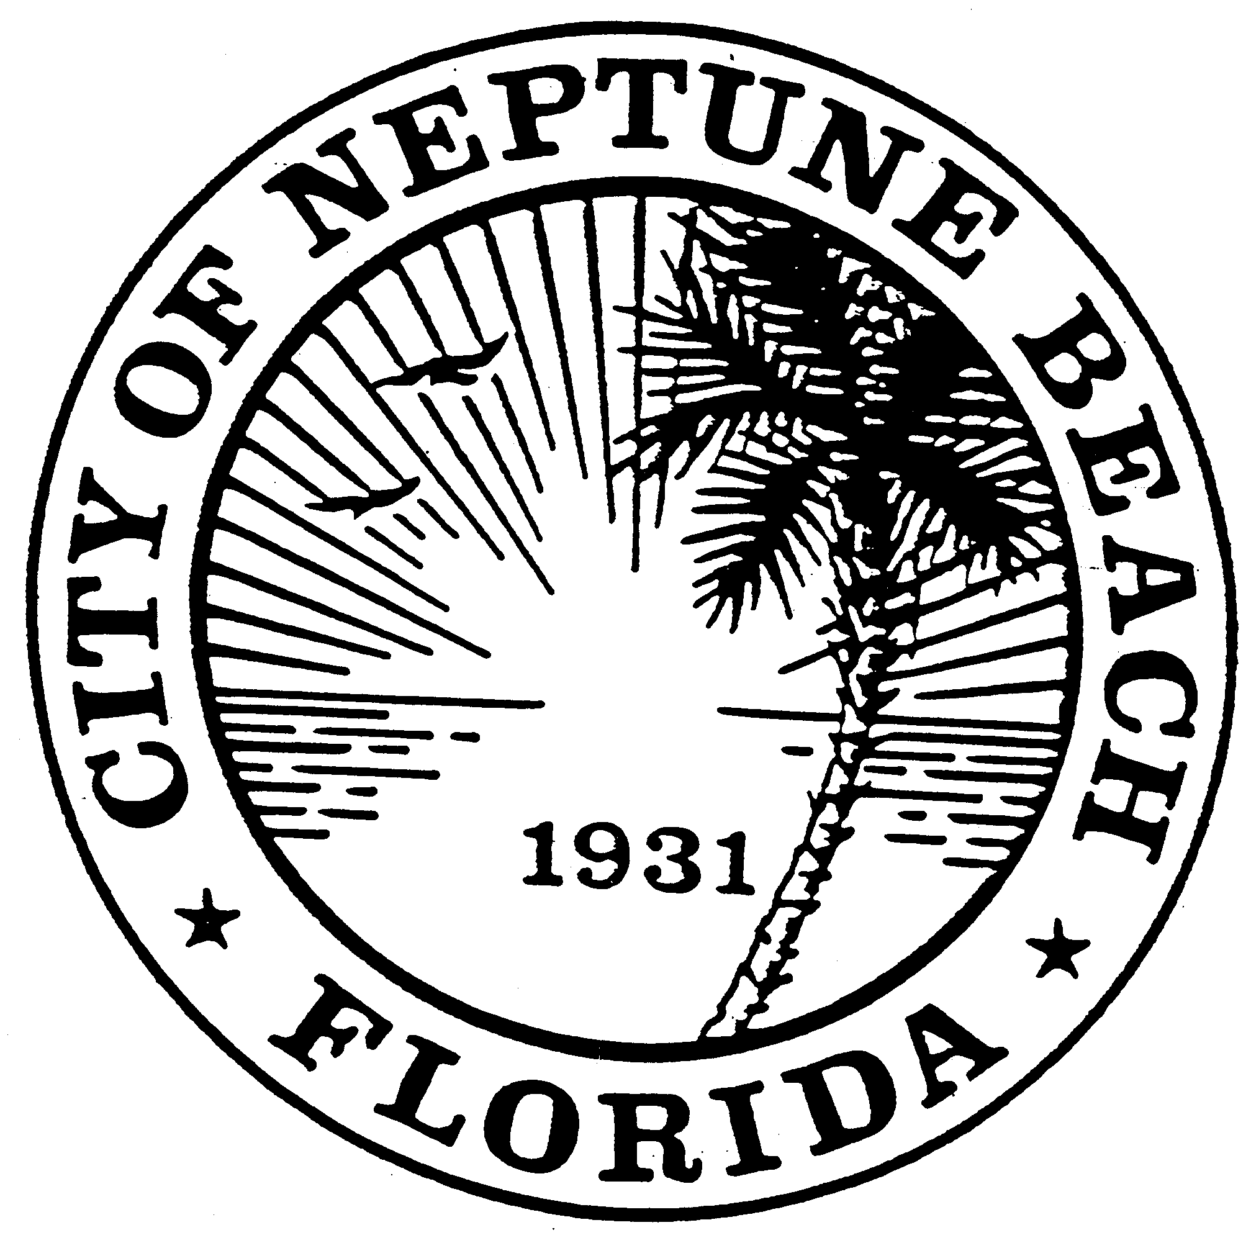

City of Neptune Beach
Community Development
116 First Street • Neptune Beach, Florida 32266-6140
(904) 270-2400 Ext. 36 • FAX (904) 270-2432

AGENDA

COMMUNITY DEVELOPMENT BOARD MEETING

SEPTEMBER 11, 2019

CITY COUNCIL CHAMBERS

116 FIRST STREET

NEPTUNE BEACH, FL 32266

- Call to Order and Roll Call.

- Disclosure of ex-parte communications.

- Approval of August 14, 2019 minutes.

- CDB V19-14 Application for variance as outlined in Chapter 27, Article 8 of the Unified Land Development Code of Neptune Beach for Gregory Todd Jones for the property known as 518 Rosebud Lane (RE#178077-2120). The request is to vary section 27-330(a)(1) to apply for an after-the-fact permit for an 8-foot-tall fence in lieu of the required 6-foot height limitation.
- Open Discussion

- Adjourn.

