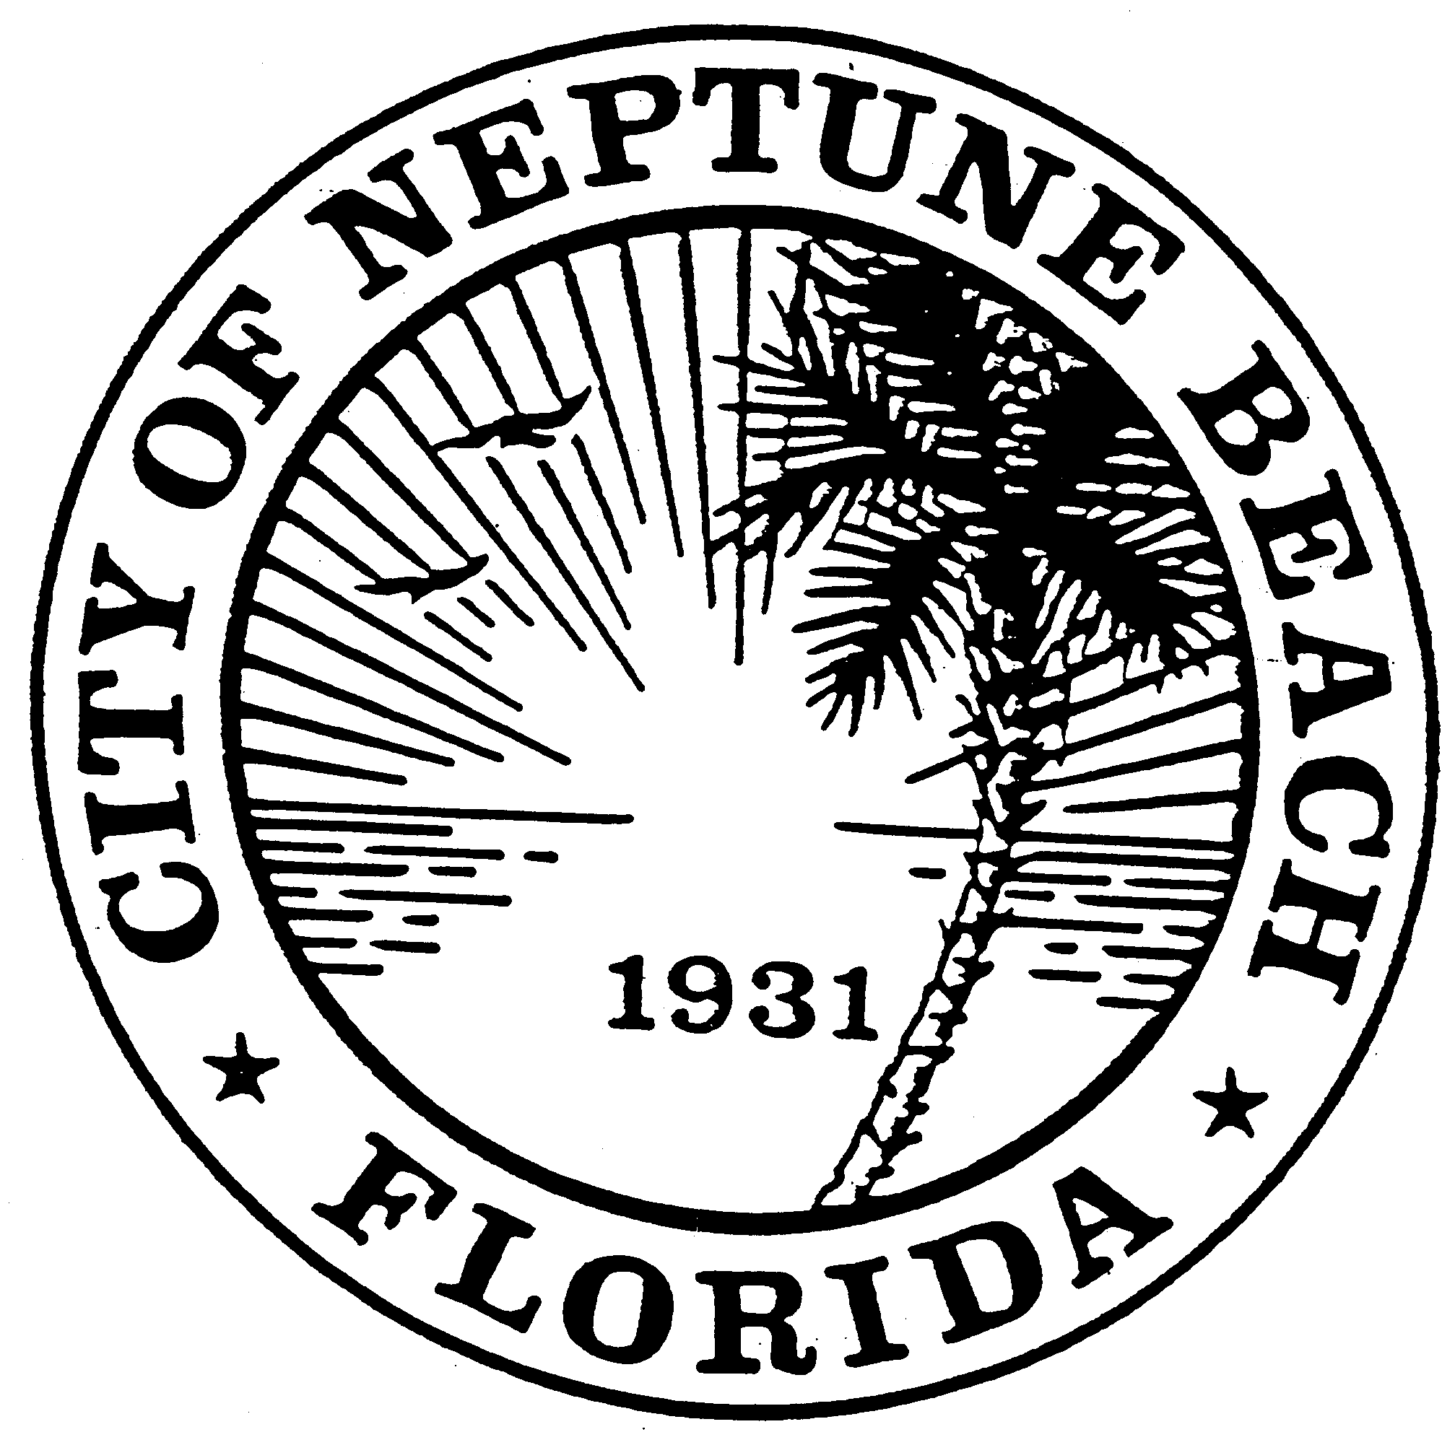

City of Neptune Beach
Planning and Community Development Department
116 First Street • Neptune Beach, Florida 32266-6140
(904) 270-2400 Ext. 36 • FAX (904) 270-2432

AGENDA

COMMUNITY DEVELOPMENT BOARD MEETING

DECEMBER 11, 2019

CITY COUNCIL CHAMBERS

116 FIRST STREET

NEPTUNE BEACH, FL 32266

- Call to Order and Roll Call.

- Training Session with the City Attorney as required by Section 27-37(m).

- Open Discussion.
- Adjourn.

