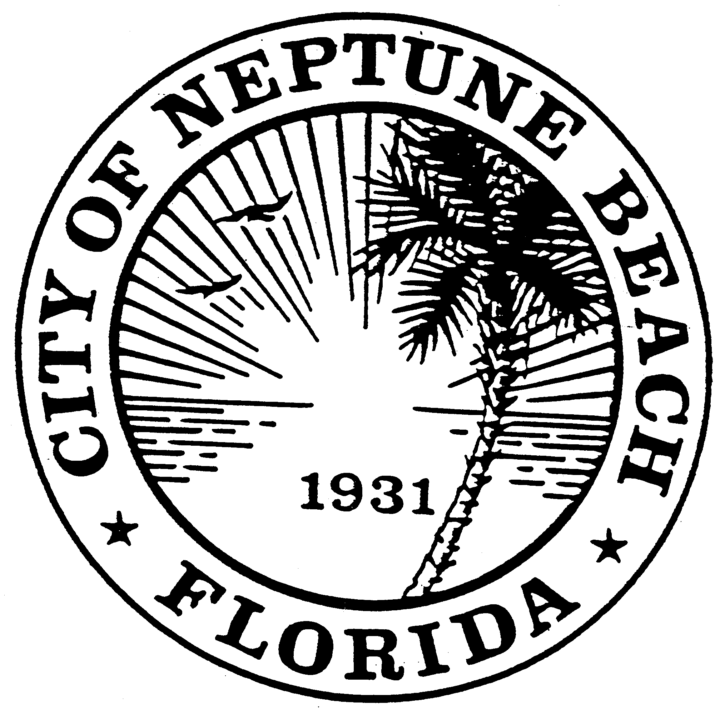

City of Neptune Beach
Community Development Department
116 First Street • Neptune Beach, Florida 32266-6140
(904) 270-2400 Ext. 36 • FAX (904) 270-2432

AGENDA

COMMUNITY DEVELOPMENT BOARD MEETING

FEBRUARY 12, 2020

CITY COUNCIL CHAMBERS

116 FIRST STREET

NEPTUNE BEACH, FL 32266

- Call to Order and Roll Call.

- Disclosure of ex-parte communications.

- Approval of the November 13, 2019 and December 12, 2019 minutes.

- CDB 20-01 Application for Replat as outlined in Chapter 27, Article 3 of the Unified Land Development Code of Neptune Beach for William L. and Jamie A. Cissel. The property is currently known as 1924 Seagate Ave, (RE# 177522-0000). The subject property is located in the R-1 zoning district. The applicants are requesting to subdivide the existing one parcel into two parcels.

- Training Session with the City Attorney as required by Section 27-37(m). Topic to be discussed with be the Sunshine Law.

- Open Discussion.
- Adjourn.

