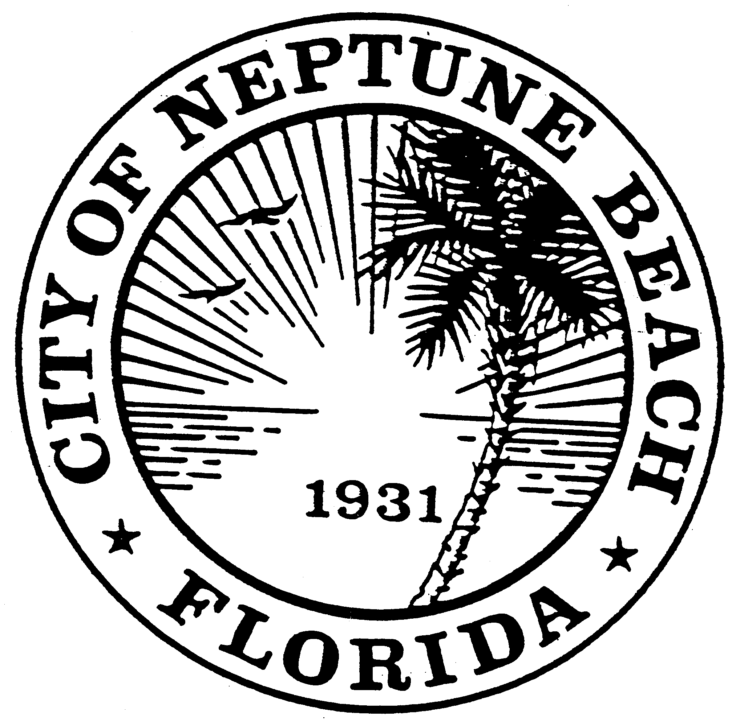

City of Neptune Beach
Planning and Community Development Department
116 First Street • Neptune Beach, Florida 32266-6140
(904) 270-2400 Ext. 34

AGENDA

COMMUNITY DEVELOPMENT BOARD MEETING

JULY 14, 2021 AT 6:00 PM

116 FIRST STREET

NEPTUNE BEACH, FL 32266

- Call to Order.
- Approval of Minutes: June 9, 2021.
- V21-08 Application for variance as outlined in Chapter 27, Article III Division 8 of the Unified Land Development Code of Neptune Beach for Justin Ebert and Lynne Taplin for the property known as 1107 Kings Road (RE#178958-0196). The request is to vary section 27-231(a) and Table 27-229-1 Front yard setbacks for the construction of an enclosed front porch and closet addition.

- V21-09 Application for variance as outlined in Chapter 27, Article III Division 8 of the Unified Land Development Code of Neptune Beach for Gordon and Amanda Stasak for the property known as 510 Pine Street (RE#172495-0000). The request is to vary section 27-232 and Table 27-229-1 Side yard setbacks for the construction of an addition.

- Open Discussion.

- Adjournment

Board Members and Residents attending public meetings can use the code XD30 to validate their parking session at no cost. After 5:30 on the date of the meeting, follow these steps:
- Make sure you are parked in a North Beaches public parking space – we can’t validate valet parking or parking in private lots.
- To use a kiosk: Using a nearby kiosk, press the Start button and then select 2 to enter your plate and the validation code.
To use the Flowbird app: Tap the nearest yellow balloon and tap “Park here.” From the payment screen, select “Redeem a code” at the top. Confirm your information and tap “Purchase”– the price will show “Free.”

