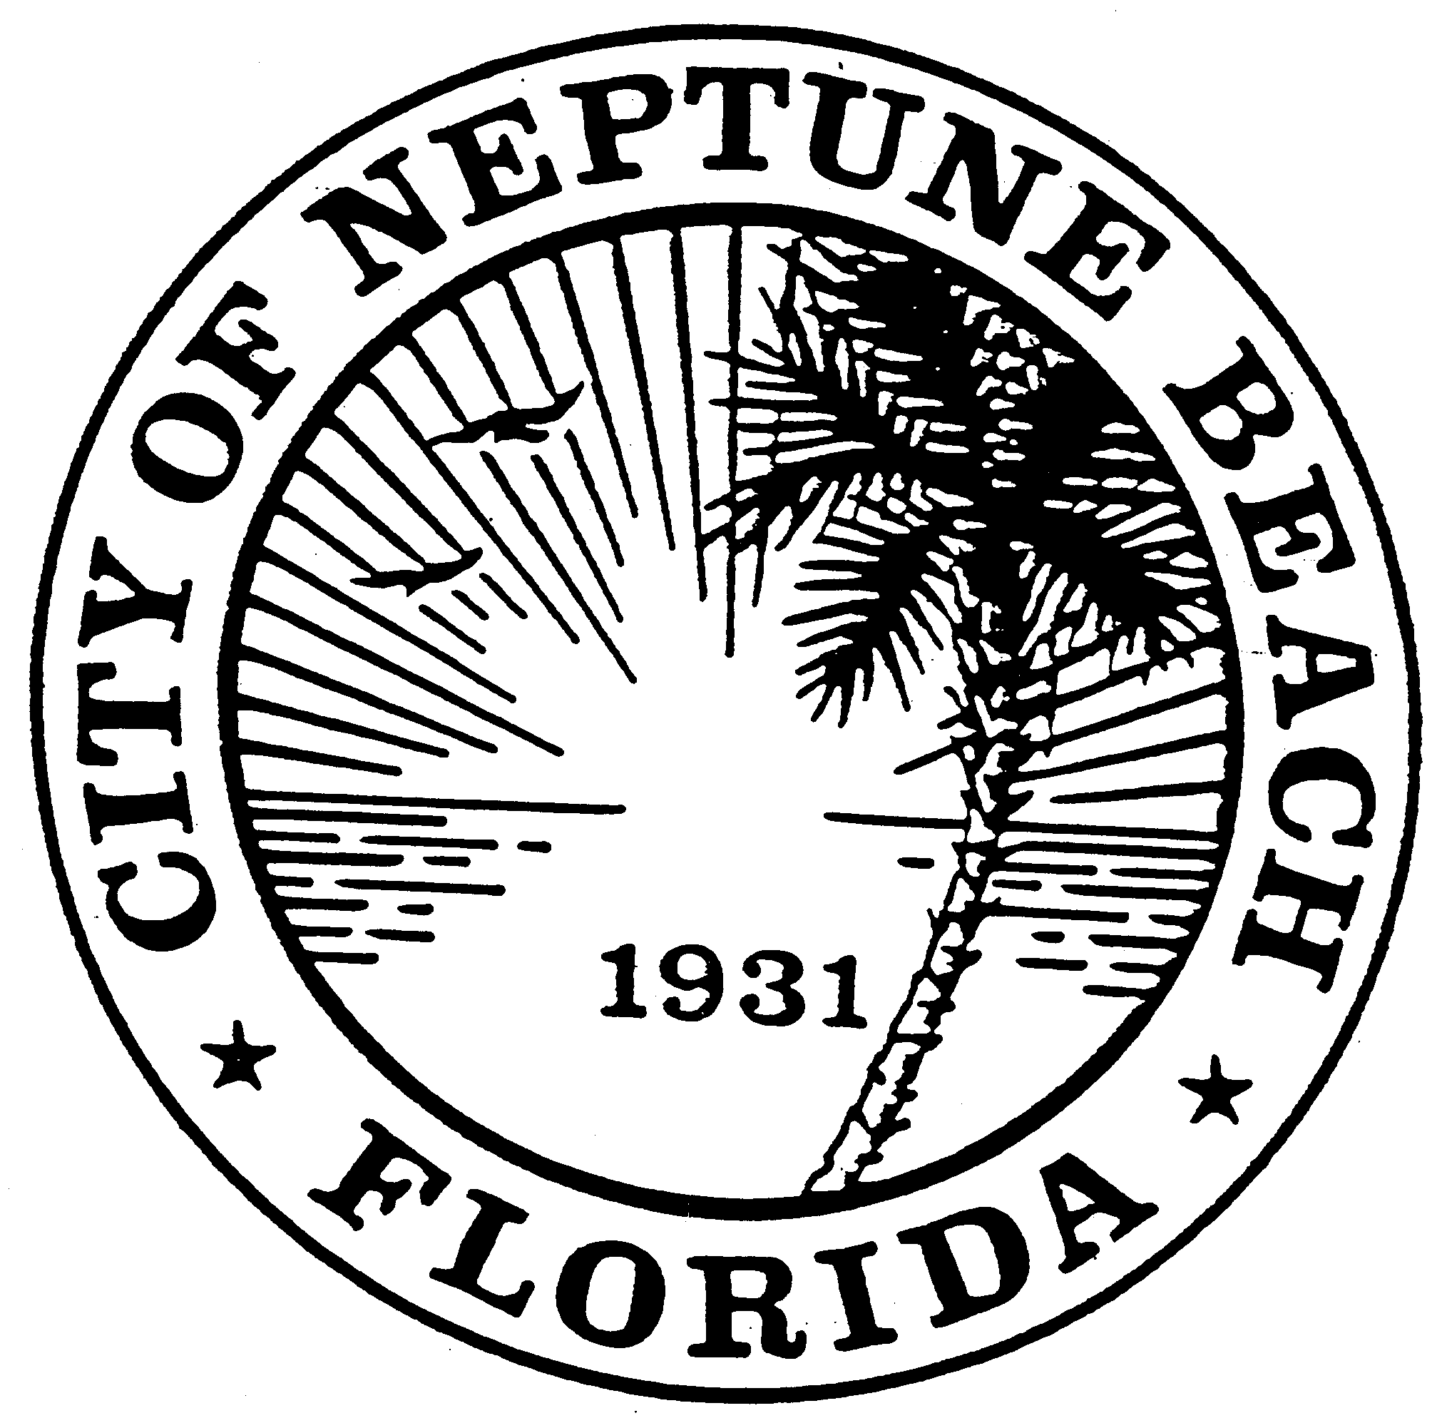

City of Neptune Beach
Community Development Department
116 First Street • Neptune Beach, Florida 32266-6140
(904) 270-2400 Ext. 36 • FAX (904) 270-2432

AGENDA

COMMUNITY DEVELOPMENT BOARD MEETING

JUNE 10, 2020

CITY COUNCIL CHAMBERS

116 FIRST STREET

NEPTUNE BEACH, FL 32266

This meeting will be a hybrid in-person meeting and a webinar conducted electronically. Space for the in-person meeting will be limited due to social distancing requirements. The webinar portion will be conducted as permitted in Governor Executive Order No. 20-69 and extended by Governor Executive Order 20-112. The City has adopted Emergency Rules Regarding to COVID-19 to Govern the Operation of Meetings of the City Council and Board of the City of Neptune Beach, which will also govern the webinar portion.

- Call to Order and Roll Call.

- Disclosure of ex-parte communications.
- Presentation by Neptune Beach FL Realty, LLC regarding the property at 580 Atlantic Blvd. The purpose of the presentation is to discuss the future of the site. No official action by the board will be taken.

- Public comments.

- Open Discussion.
- Adjourn.

