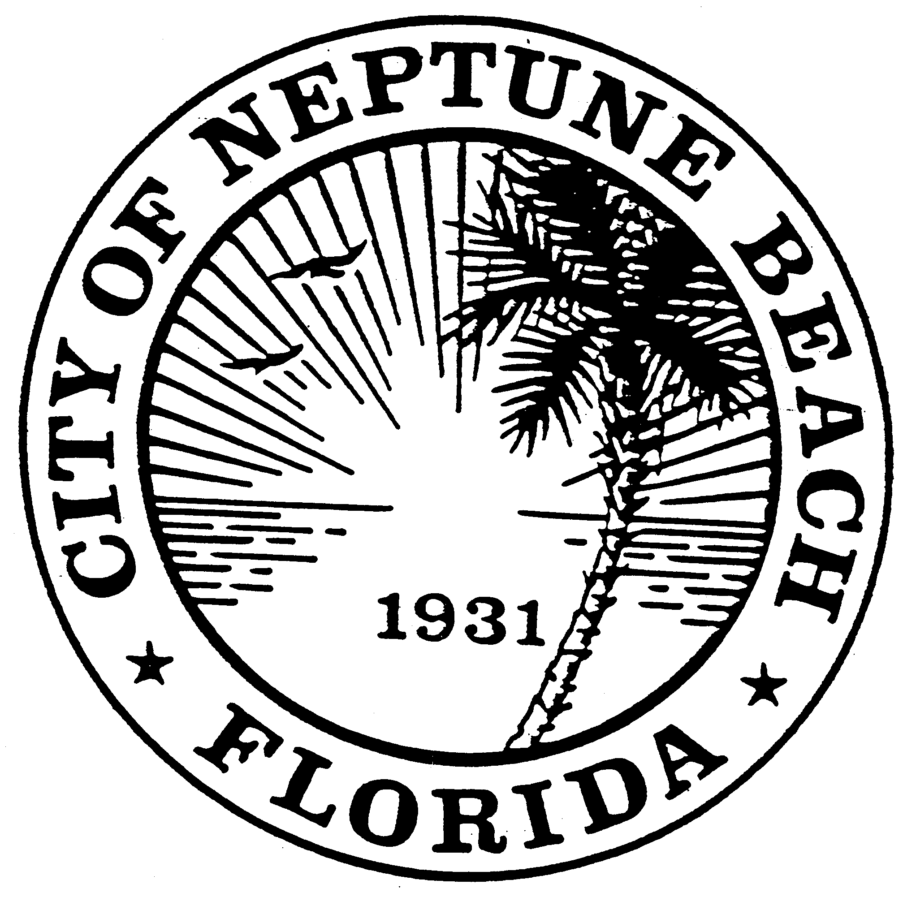

City of Neptune Beach
Planning and Community Development Department
116 First Street • Neptune Beach, Florida 32266-6140
(904) 270-2400 Ext. 36

AGENDA

COMMUNITY DEVELOPMENT BOARD MEETING

JUNE 9, 2021 AT 6:00 PM

116 FIRST STREET

NEPTUNE BEACH, FL 32266

(AMENDED)

- Call to Order.
- Approval of Minutes: May 12, 2021.
- V21-07 Application for variance as outlined in Chapter 27, Article III Division 8 of the Unified Land Development Code of Neptune Beach for Gina Cavallo for the property known as 228 South Street (RE#173152-0500). The request is to vary section 27-238(4) Maximum lot coverage and section 27-329(2) Swimming pool setbacks for the construction of a swimming pool.

- CDB21-02 Application for Development Permit review as outlined in Chapter 27, Article 3 Division 2 of the Unified Land Development Code of Neptune Beach for Shorebreak Ventures, LLC for the property known as 310 Third Street (RE# 172912-0010). This property is in the C-1 zoning district. The applicant is proposing to build a new two-story office building with parking under the building.

- SE21-02 Application for a special exception as outlined in Chapter 27, Article 3 Division 9 of the Unified Land Development Code for Shorebreak Ventures, LLC for the property known as 310 Third Street (RE# 172912-0010). The request is in response to Section 27-548(a)(1) Off-street parking requirements and Section 27-545 Deferral of parking requirements.
- Second review of the first draft of the 2021-2046 Comprehensive Plan, to later be known as Ordinance 21-03, along with the Future Land Use Map for The City of Neptune Beach, Florida. The Comprehensive Plan as Ordinance 21-03 and accompanying Future Land Use Map to be considered for transmittal by City Council at a later date as required by Florida State Statute, followed by the consideration of adoption by City Council following the review by the State of Florida.
- Open Discussion.

- Adjournment

Board Members and Residents attending public meetings can use the code XD30 to validate their parking session at no cost. After 5:30 on the date of the meeting, follow these steps:
- Make sure you are parked in a North Beaches public parking space – we can’t validate valet parking or parking in private lots.
- To use a kiosk: Using a nearby kiosk, press the Start button and then select 2 to enter your plate and the validation code.
To use the Flowbird app: Tap the nearest yellow balloon and tap “Park here.” From the payment screen, select “Redeem a code” at the top. Confirm your information and tap “Purchase”– the price will show “Free.”

