 |  |  | 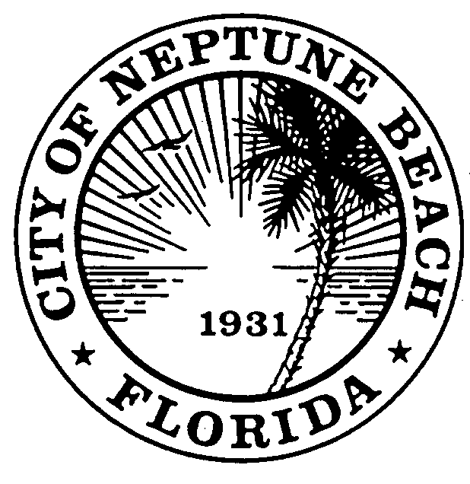
MINUTES
COMMUNITY DEVELOPMENT BOARD
NOVEMBER 10, 2021 AT 6:00 P.M.
COUNCIL CHAMBERS
116 FIRST STREET
NEPTUNE BEACH, FLORIDA 32266

 |  |  | Pursuant to proper notice a public hearing of the Community Development Board for the City of Neptune Beach was held on November 10, 2021 at 6:00 p.m. in the Council Chambers.
 |  | Attendance |  |  | Board members were in attendance:  Charley Miller, Member  Nia Livingston, Member  Bob Frosio, Member  Greg Schwartzenberger, Alternate Member
The following staff members were present:
Zach Roth, City Attorney
Kristina Wright, Community Development Director
Piper Turner, Code Compliance Supervisor
 |  | Call to Order  Roll Call |  |  | Vice-Chair Livingston called the meeting to order at 6:03 p.m.
 |  | Ex Parte Communications |  |  | There was no communication between the applicants and themselves prior to the meeting.
 | Minutes |  |  | Made by Miller, seconded by Schwartzenberger.
MOTION: | TO APPROVE OCTOBER 13, 2021 MINUTES AS SUBMITTED.
Roll Call Vote:
Ayes: | 4 -Miller, Schwartzenberger, Raitti, Frosio, Livingston
Noes: | 0
MOTION CARRIED

 | CDB 21-04 Application for a Special Exception to modify the Outdoor Seating 1455 Atlantic Blvd |  |  |  | SE21-04 Application for a new special exception to modify the outdoor dining as outlined in Chapter 1, Article 3, Division 9 of the United Land Development Code for MNCW, LLC for the property known as 1455 Atlantic BLVD. The request is to build an awning type of structure to cover the existing outdoor seating area. The original special exception for outdoor dining was granted on October 1, 2012. No additional seating capacity is being requested.
 |  |  |  |  |  | Kristina Wright stated that the applicant is seeking to add an awning to an existing outdoor seating area that was granted a special exception for outdoor dining on October 1, 2012. The applicant is not requesting any additional seating capacity and is only looking to cover the existing seating area. The original request was heard by the Community Development Board on September 19, 2012. The CDB recommended approval and the agenda item was forwarded to and unanimously approved by the City Council on October 1, 2012.
Sec. 27-160 Required Findings Needed to Recommend a Special Exception

- Is the proposed use consistent with the Comprehensive Plan?
The comprehensive plan for the plaza is to promote foot traffic. By offering shaded, outdoor seating, we will be a cornerstone of entertainment and a destination for patrons to come and enjoy this facility as well as Neptune Beach as a whole.

- Is the proposed use compatible with the general character of the area, considering the population density; the design, density, scale, location, and orientation of existing and permissible structures in the area; property values; and the location of existing similar uses?
Our proposed use will be completely compatible with all aspects of the general character of this area. We will add more covered space to the complex and add more family-friendly seating, which will also add to the property values and overall appeal.

- Will the proposed use have an environmental impact that is inconsistent with the health, safety, and welfare of the community?
There is nothing involved with the proposed special exception that would negatively affect any aspect of the welfare of the community.

- Will the proposed use generate or otherwise cause conditions that would have a detrimental effect on vehicular traffic, pedestrian movement, or parking inconsistent with the health, safety, and welfare of the community?
Since we are already an existing business, we will not negatively affect any movement or parking conditions. The seating will not be affected to a point where it will have any effect on the health, safety and/or welfare of the community.

- Will the proposed use have a detrimental effect on the future development of the area as allowed in the Comprehensive Plan?
By our establishment already being a consistent and valued restaurant for our community, our continued success will only serve to further develop this area as a tourist destination. This makes our success important to the Comprehensive Plan.

- Will the proposed use result in the creation of objectionable or excessive noise, light, vibration, fumes, odors, dust, or physical activities inconsistent with existing or permissible uses in the area?
No concerns.

- Will the proposed use overburden existing public services and facilities?
Have been in business for well over a year, we feel more than confident that the proposed use will not affect the existing public service facilities or how they function.

- Does the proposed use meet all other requirements as provided for elsewhere in the Code?
The requirements in Chapter 27 and the Comprehensive Plan are not being compromised by the proposed use. Existing parking and/traffic will also not be affected.

Staff Recommendation
Staff recommends approval of SE 21-04 1455 Atlantic Blvd.
 |  |  |  |  |  | Mr. Mark Monroy, restaurant owner, addressed the board. They would like to install an awning over to the existing outdoor seating area. This will allow them to offer outdoor dining during colder weather with heaters being added and have doggie dining. This will give the customers an alterative dining option.
 |  |  | Made by Frosio, seconded by Miller.
 |  |  | MOTION: |  |  |  |  |  | TO RECOMMEND APPROVAL OF THE SPECIAL EXCEPTION SE 21-04 FOR 1455 ATLANTIC BLVD TO BUILD AN AWNING TYPE STRUCTURE TO COVER THE EXISTING OUTDOOR DINING. NO ADDITIONAL SEATING CAPACITY IS GRANTED.
 |  |  | Roll Call:
 |  |  | Ayes: |  |  |  |  |  | 4-Miller, Schwartzenberger, Frosio. Livingston
 |  |  | Noes: |  |  |  |  |  | 0
 |  |  | MOTION APPROVED.
 |  |  | The applicant was informed that the City Council makes the final decision and they should attend the Monday December 6, 2021 meeting at 6:00 pm.
Open Discussion |  |  |  |  |  |  | The comprehensive plan has been approved. The rewrite of the ULDC will be presented to the board in 2022.
 |  | Adjournment |  | There being no further business, the meeting adjourned at 6:17 p.m.
 |  |  |  |  |  |  |  |  |  | Board Chair
ATTEST:

Piper Turner, Board Secretary

